1. An Organization with three departments has planned to connect their employees mobile phone, I-phone , laptop and tablets by wireless connection, Propose a design for the same.

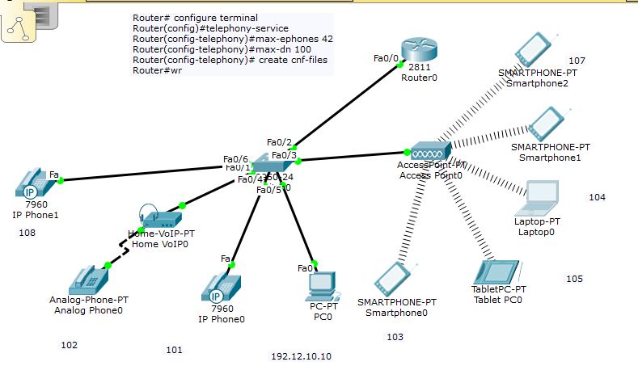

The solution is divided into Three Parts

**Part1**

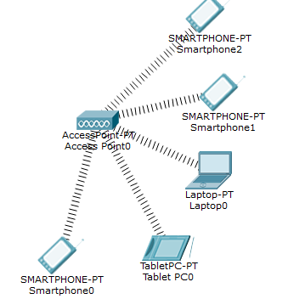Step 1

Access Point

Set the SSID and Password

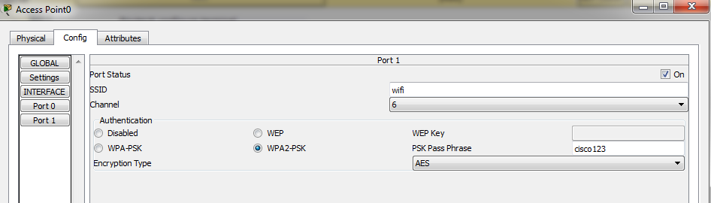

Step 2

Connect the mobile phone to access Point

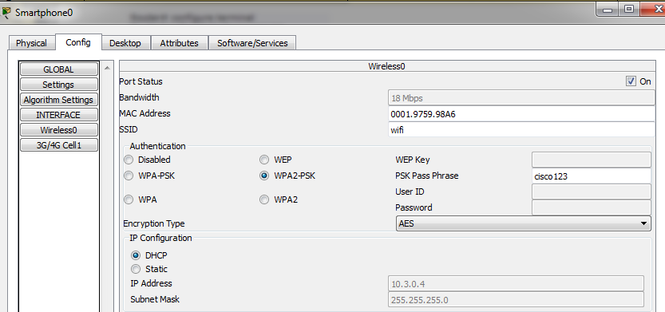

Step 3 connect laptop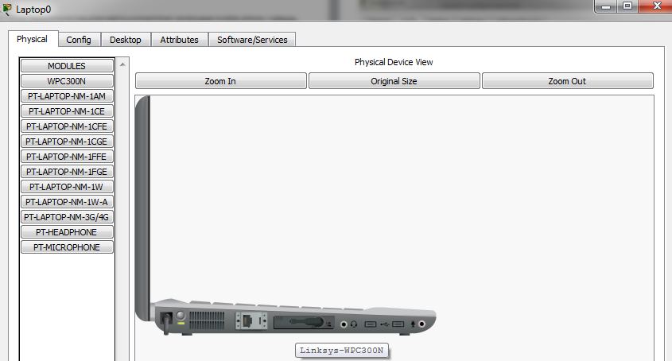

Switch off the Laptop and replace the wired module by wireless module WPC300N and again on the laptop.

Step 4 :

Connect the laptop to the Access Point

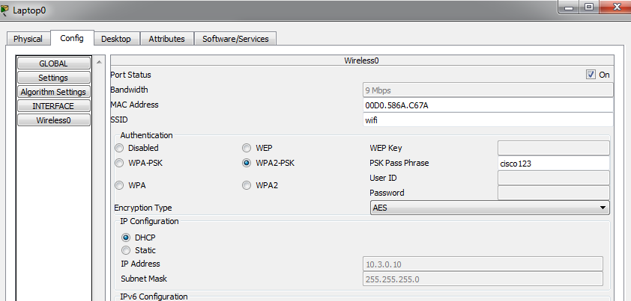

Part 2

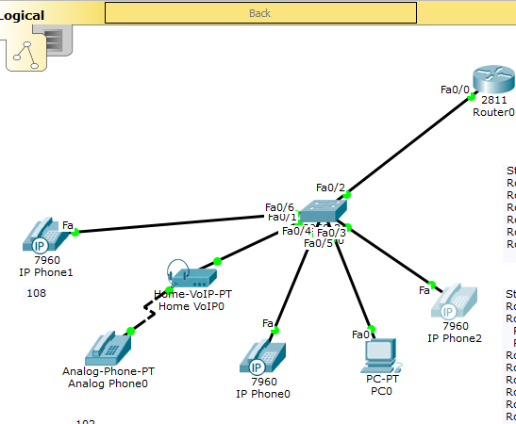

Part2

Power on IPPhone

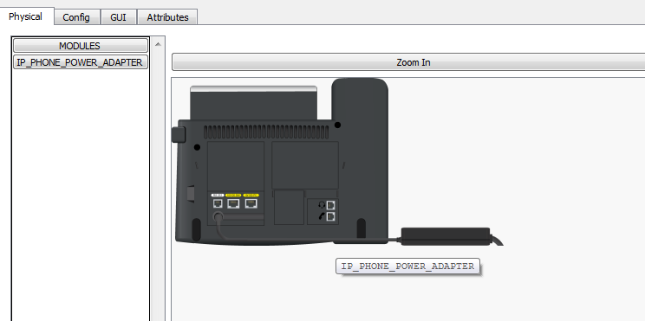

Tasks 1 : Configure interface FastEthernet 0/0 and DHCP server on RouterA (2811 router)

#Configure the FA 0/0 interface#

RouterA>enable

RouterA#configure terminal

RouterA(config)#interface FastEthernet0/0

RouterA(config-if)#ip address 192.168.10.1 255.255.255.0

RouterA(config-if)#no shutdown

The DHCP server is needed to provide an IP adress and the TFTP server location for each IP phone connected to the network.

RouterA(config)#ip dhcp pool VOICE #Create DHCP pool named VOICE

RouterA(dhcp-config)#network 192.168.10.0 255.255.255.0 #DHCP network network 192.168.10 with /24 mask#

RouterA(dhcp-config)#default-router 192.168.10.1 #The default router IP address#

RouterA(dhcp-config)#option 150 ip 192.168.10.1 #Mandatory for voip configuration.

After the configuration, wait a moment and check that ‘IP Phone 1’ has received an IP address by placing your cursor over the phone until a configuration summary appears.

Tasks 2 : Configure the Call Manager Express telephony service on RouterA

You must now configure the Call Manager Express telephony service on RouterA to enable voip on your network.

RouterA(config)#telephony-service #Configuring the router for telephony services#

RouterA(config-telephony)#max-dn 5 #Define the maximum number of directory numbers#

RouterA(config-telephony)#max-ephones 5 #Define the maximum number of phones#

RouterA(config-telephony)#ip source-address 192.168.10.1 port 2000 #IP Address source#

RouterA(config-telephony)#auto assign 4 to 6 #Automatically assigning ext numbers to buttons#

RouterA(config-telephony)#auto assign 1 to 5 #Automatically assigning ext numbers to buttons#

Task 4 : Configure a voice vlan on SwitchA

Apply the following configuration on SwitchA interfaces. This configuration will separate voice and data traffic in different vlans on SwitchA. data packets will be carried on the access vlan.

SwitchA(config)#interface range fa0/1 – 5 #Configure interface range#

SwitchA(config-if-range)#switchport mode access

SwitchA(config-if-range)#switchport voice vlan 1 #Define the VLAN on which voice packets will be handled#

Task 5 : Configure the phone directory for IP Phone 1

Although ‘IP Phone 1’ is already connected to SwitchA, it needs additionnal configuration before beeing able to communicate. You need to configure RouterA CME to assign a phone number to this IP phone.

RouterA(config)#ephone-dn 1 #Defining the first directory entry#

RouterA(config-ephone-dn)#number 54001 #Assign the phone number to this entry#

Task 5 : Verify the configuration

Ensure that the IP Phone receives an IP Address and a the phone number 54001 from RouterA (this can take a short while).

This is for PC

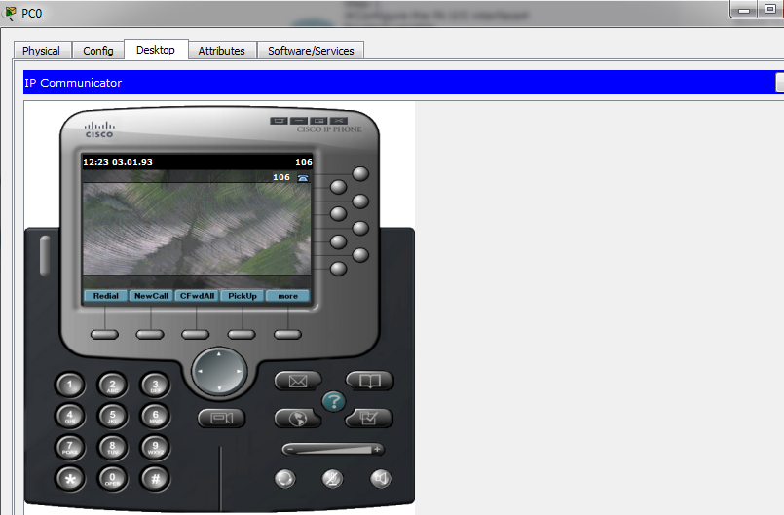

This is for IP Phone

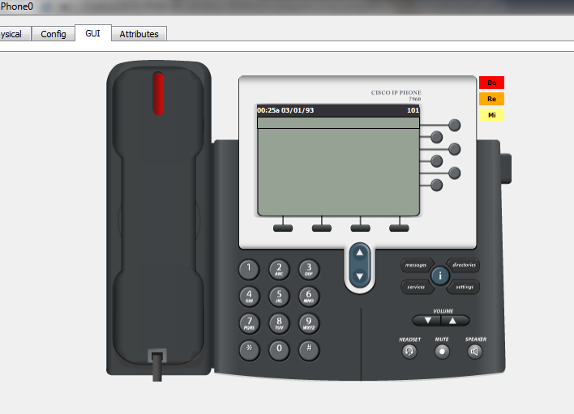

Verify by Calling

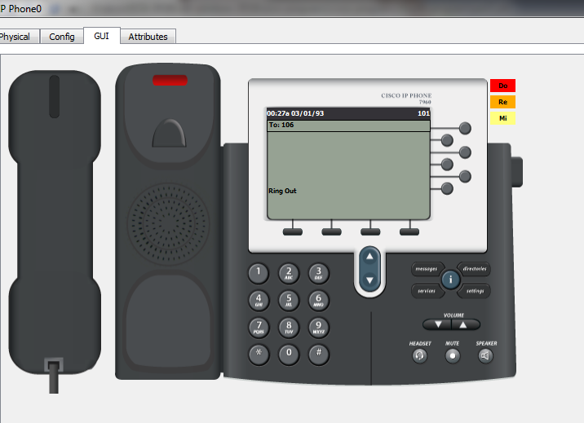

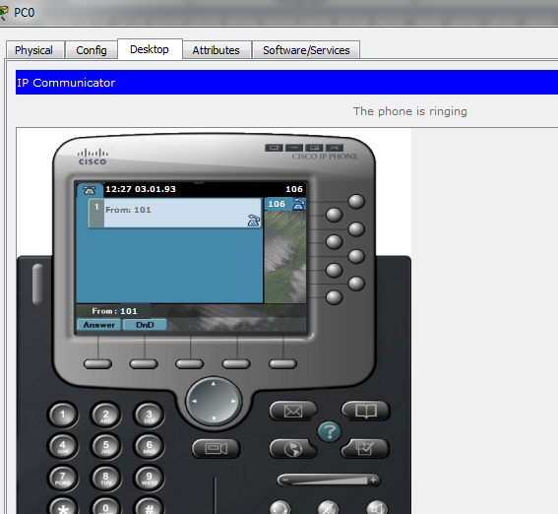

Part 3

Connect Switch to the Access Point

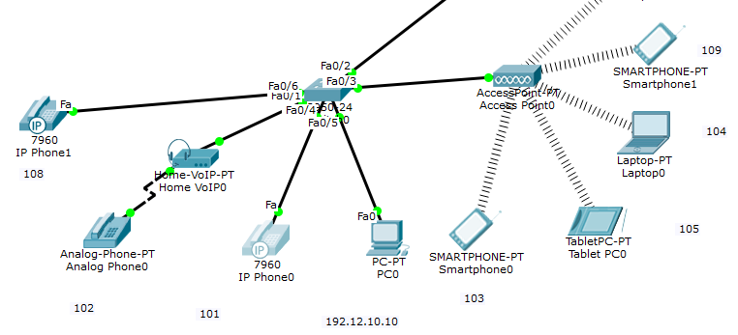

Call smart Phone to IpPhone with 101

